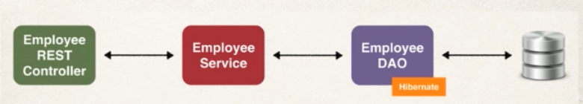

Here we will go in 3 steps to get data from database, first we define the route in controller and ask for service which will fetch data using the DAO, finally it will fetch data from database.

Now we can use many DAO techniques.

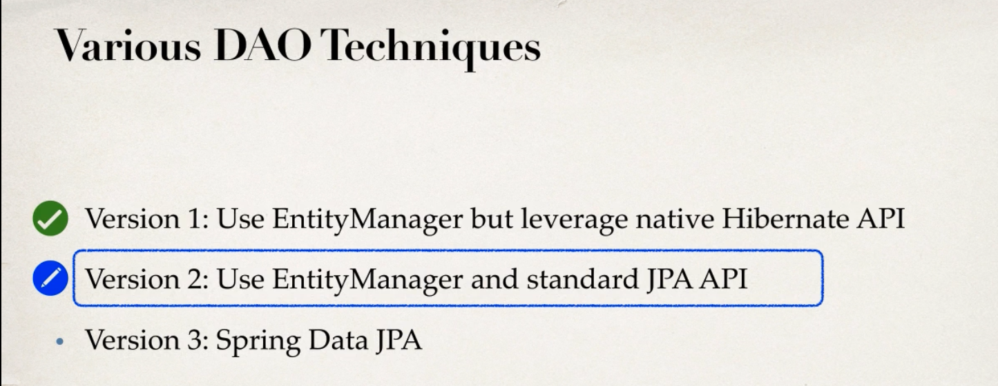

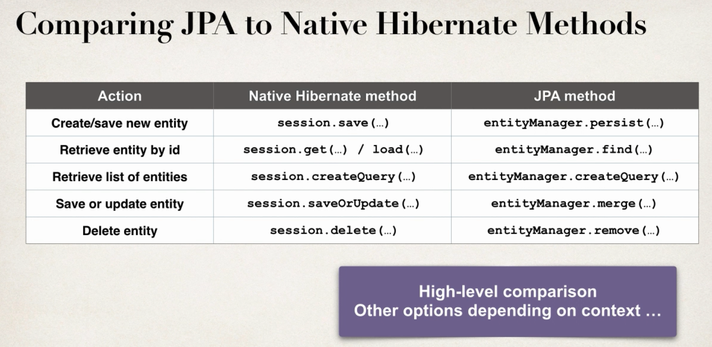

First two version need us to implement everything, but the last version using spring Data JPA, we get access to basic CRUD operations and many more.

